**Teejay Madlangbayan**

F24 PROG1322-01 Design Patterns

Student Number : 4518838

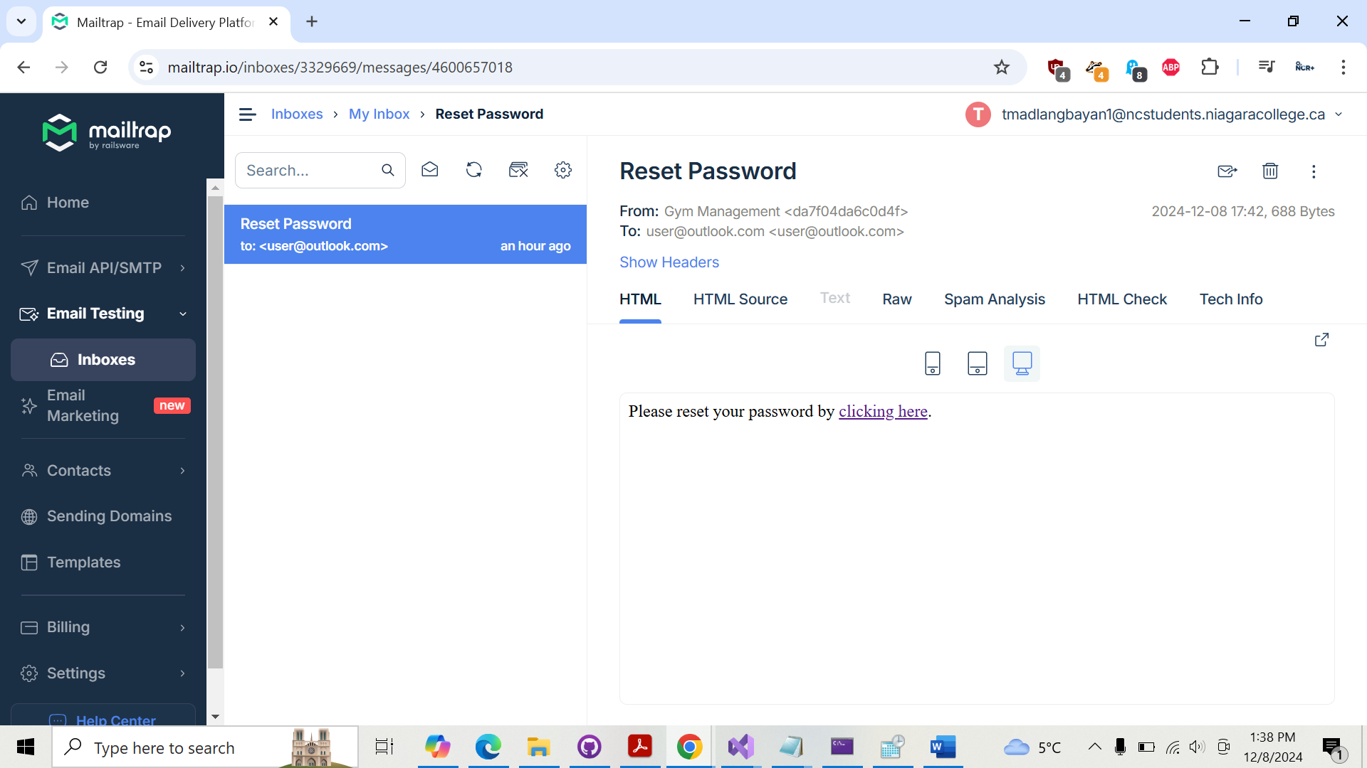

**Reset Password**

From:Gym Management <da7f04da6c0d4f>

To:user@outlook.com [user@outlook.com](mailto:user@outlook.com)

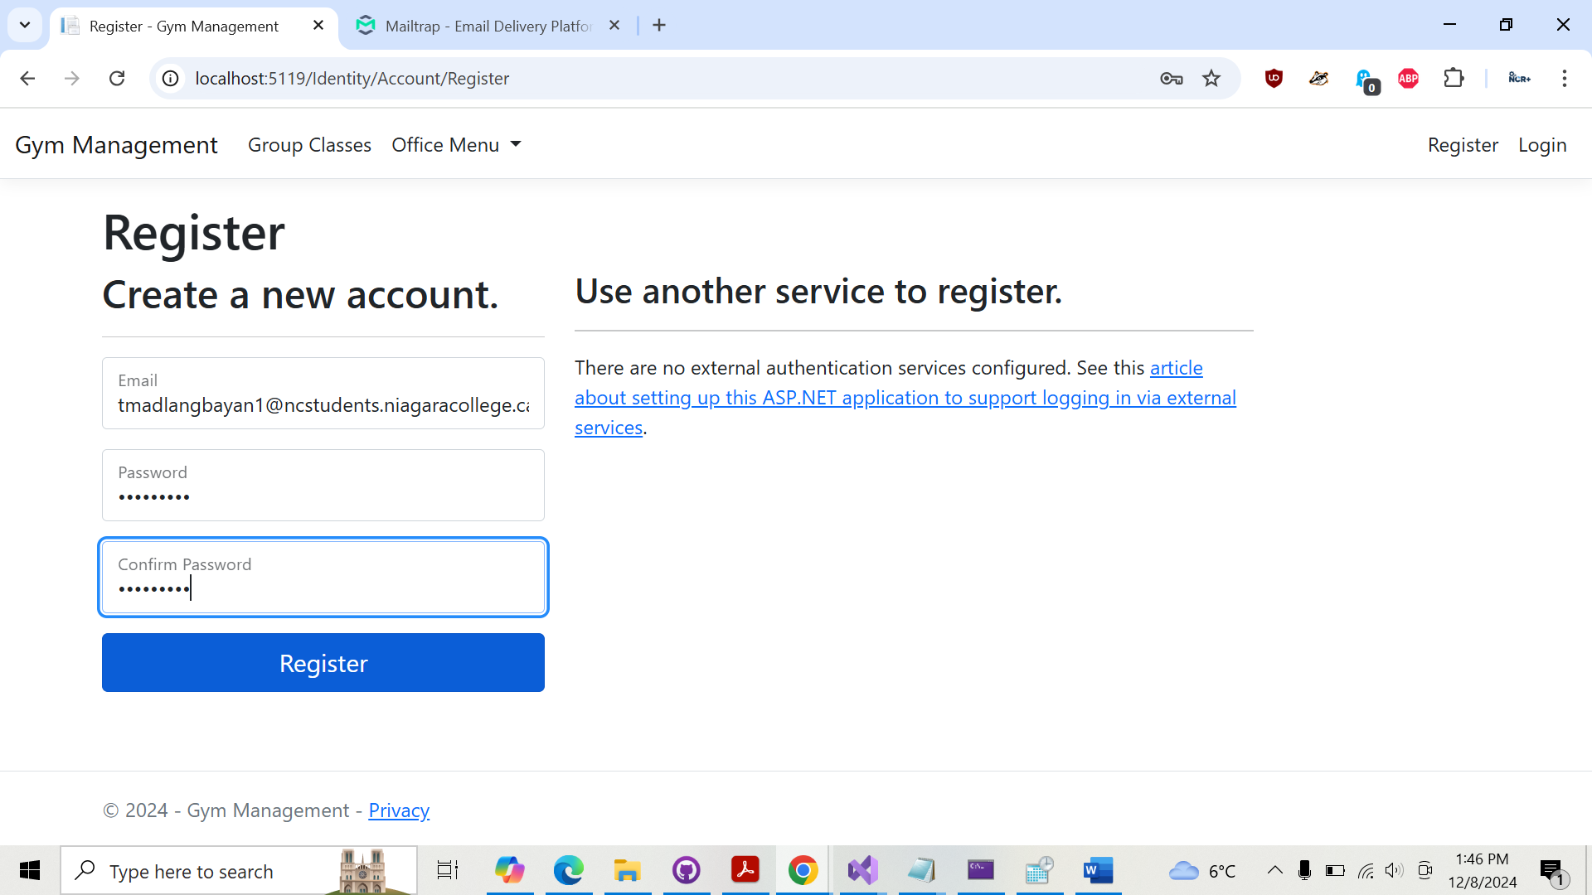

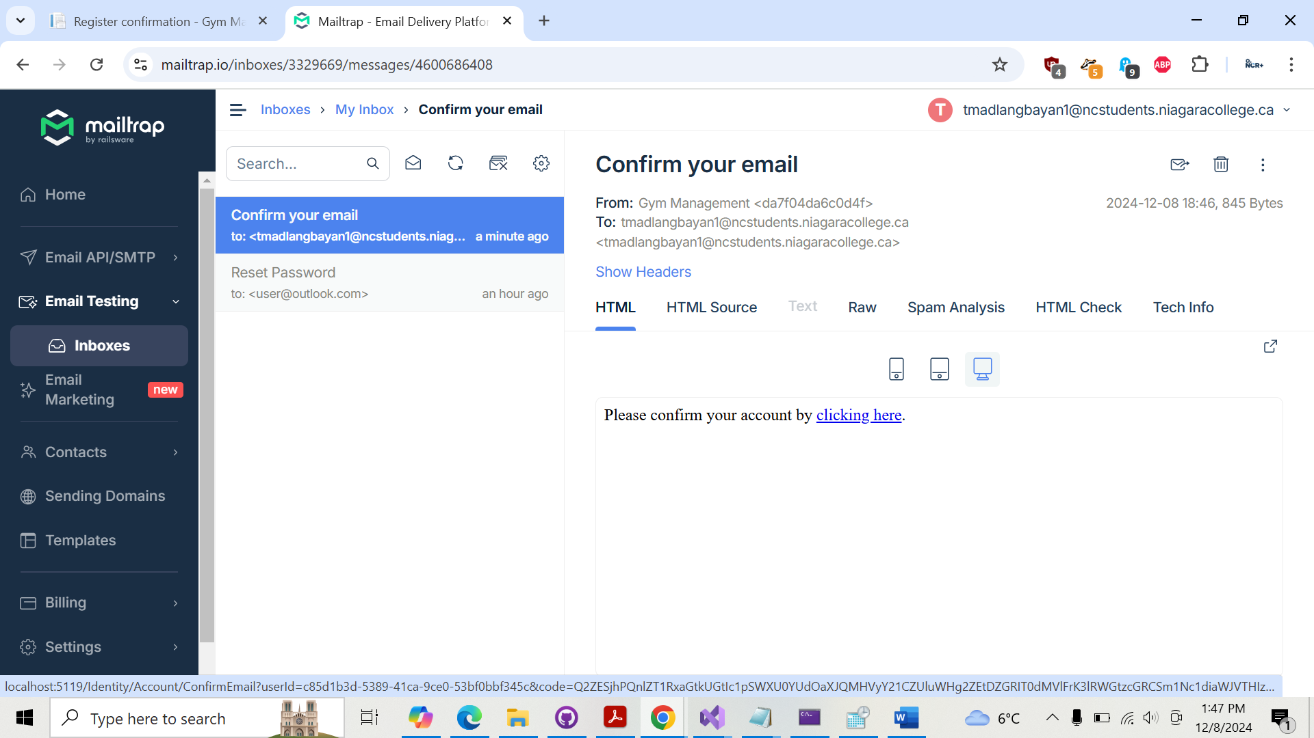

**Confirm your email**

From:Gym Management <da7f04da6c0d4f>

To:tmadlangbayan1@ncstudents.niagaracollege.ca <tmadlangbayan1@ncstudents.niagaracollege.ca>

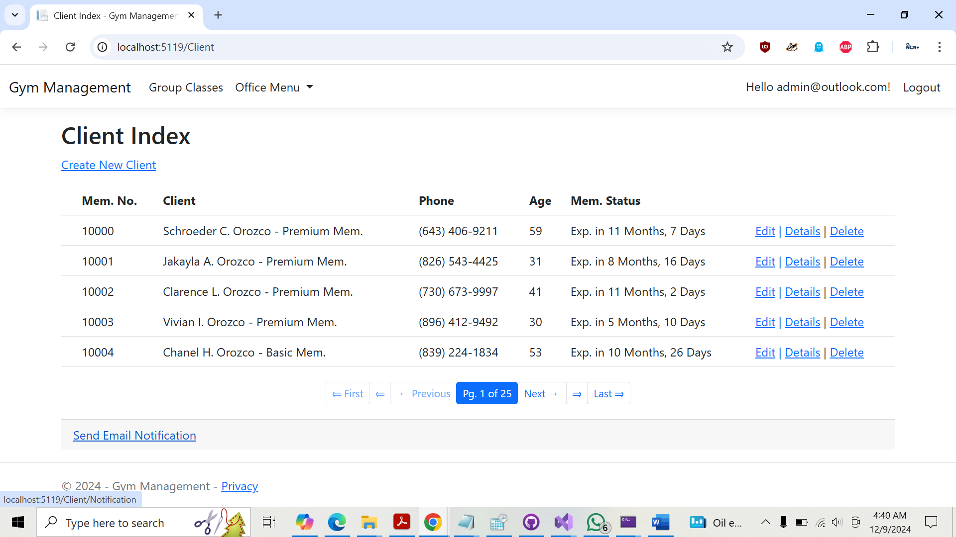

**Send Email Notification** found in **Client Index**

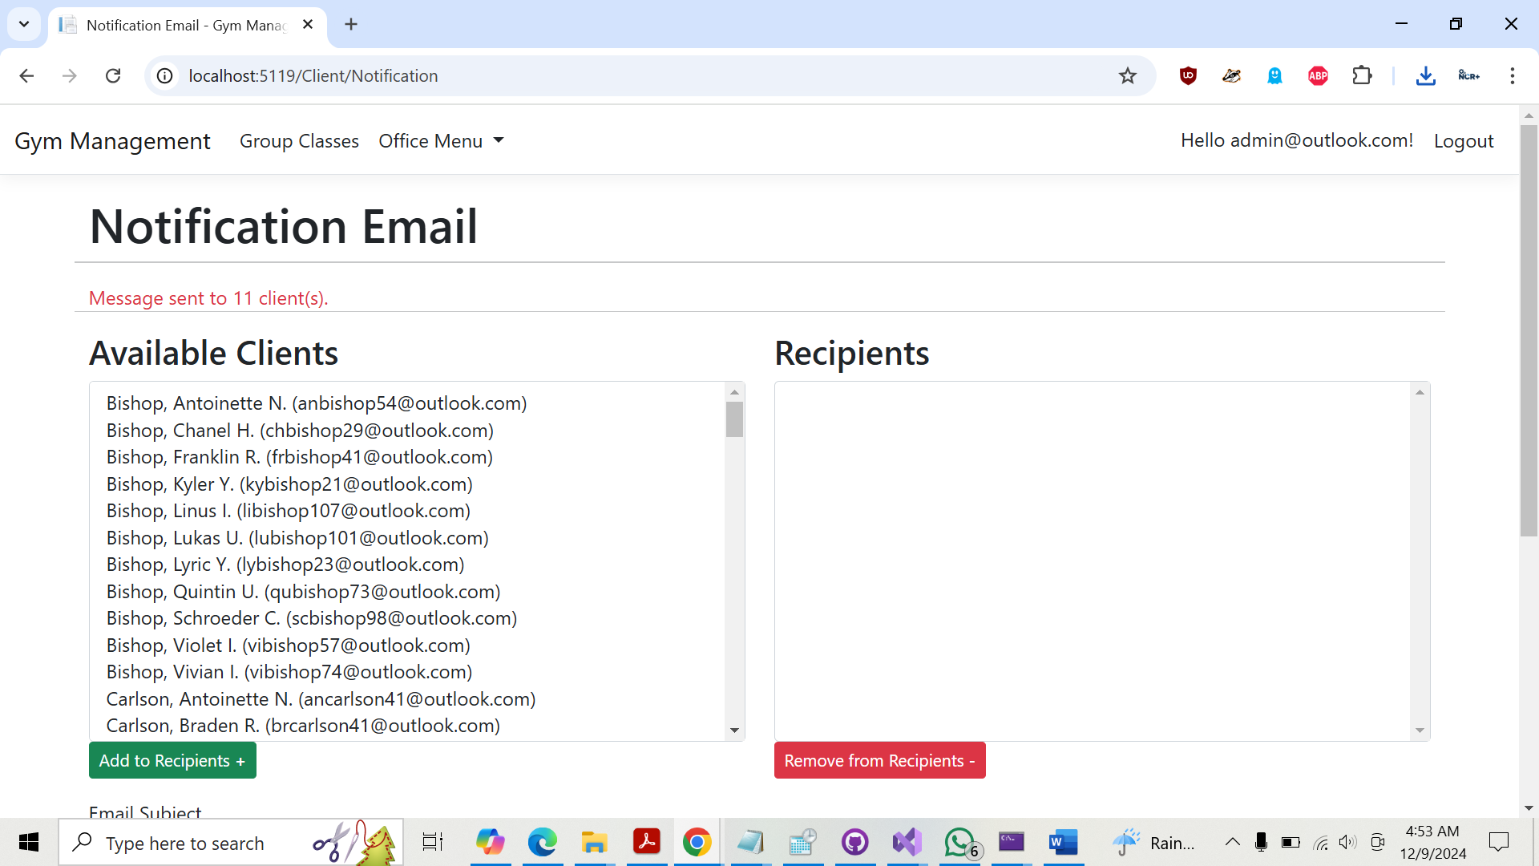

**Message sent to 11 client(s).**

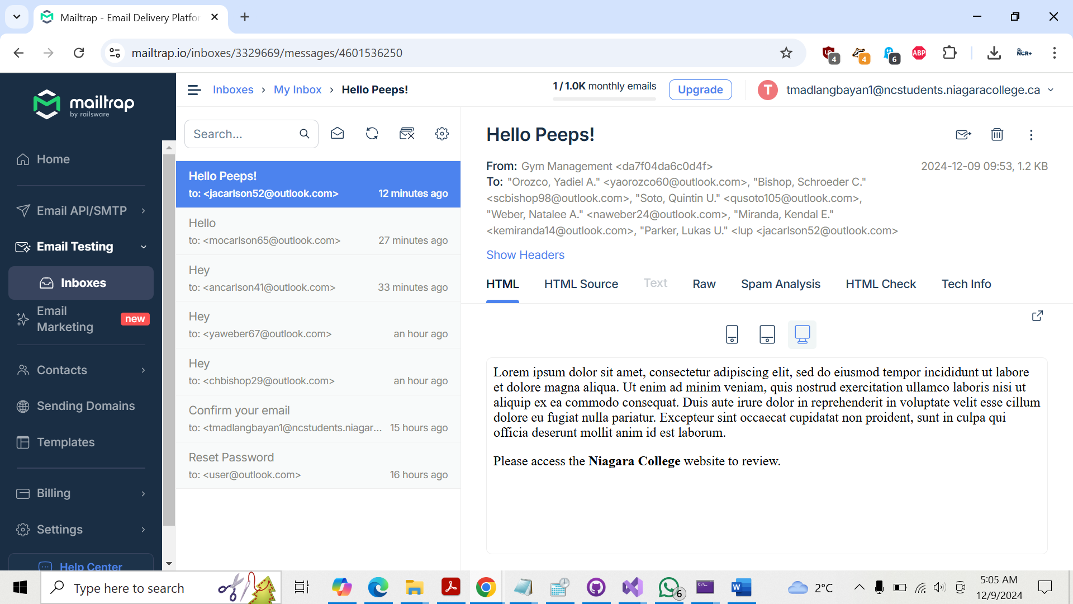

**Hello Peeps!**

From:Gym Management <da7f04da6c0d4f>

To:"Orozco, Yadiel A." <yaorozco60@outlook.com>, "Bishop, Schroeder C." <scbishop98@outlook.com>, "Soto, Quintin U." <qusoto105@outlook.com>, "Weber, Natalee A." <naweber24@outlook.com>, "Miranda, Kendal E." <kemiranda14@outlook.com>, "Parker, Lukas U." <lup <jacarlson52@outlook.com>